GRDC | RCSN

Regional Cropping Solutions Network
NEW MEMBER EXPRESSION OF INTEREST 2019

INTRODUCTION

Thank you for your interest in being a member of your local Regional Cropping Solutions Network (RCSN). This New Expression of Interest (EOI) provides general information about the RCSN, along with information on the roles and responsibilities of members.

We look forward to receiving your New Member EOI form, which is found at the end of this document. Please submit this via email to rcsnwesteoi@gmail.com by 31st May, 2019.

ABOUT THE RCSNs

The Grains Research and Development Corporation (GRDC) has established the Regional Cropping Solutions Networks (RCSN) to better plan and design local activities of the greatest benefit to their Zone. These services are complimentary to the National Grains Industry Research, Development and Extension Strategy.

The RCSN provides a structure for a region’s growers, advisers, researchers and agribusiness to come together to identify, collate and prioritise research needs, as well as to feed information back to growers. The networks also nominate representatives to the National Variety Trials (NVT) Advisory Committee, and other committees as required. An important objective of this structure is to reduce the time taken for new varieties, practices and technologies to be adopted.

In Western Australia there are five networks supported by a facilitator, Julianne Hill. A Western Panel member is also associated with each RSCN. As well as prioritising research ideas and providing feedback to the GRDC Western Panel, each RCSN provides guidance to RCSN and GRDC staff in developing projects to address the issues they have prioritized.

RCSN ZONES IN WESTERN AUSTRALIA
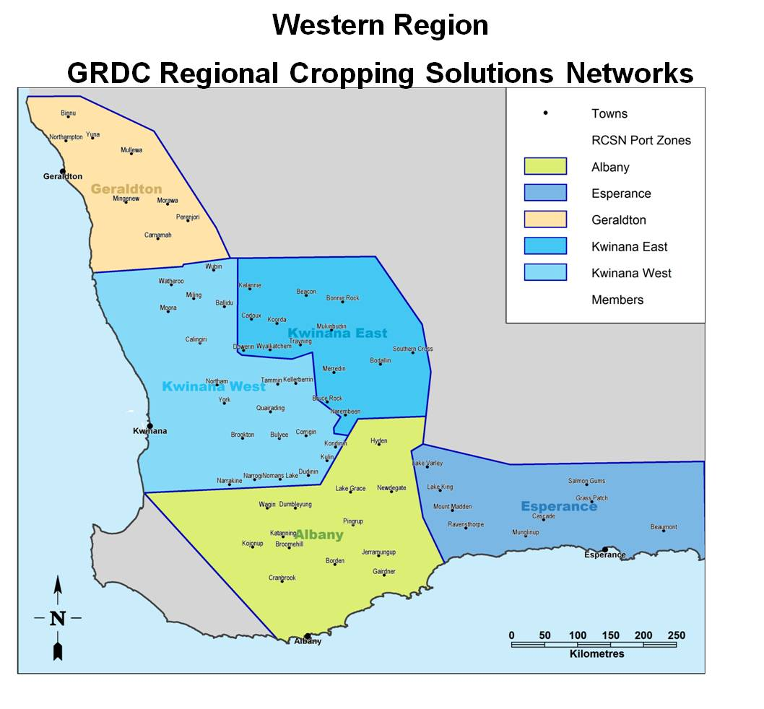
In Western Australia the RCSN Zones include:

• Geraldton Port Zone
• Kwinana West Port Zone
• Kwinana East Port Zone
• Esperance Port Zone
• Albany Port Zone.

You can find out more about the Western Regional Panel and the Zones here: www.rcsn.net.au

ABOUT THE MEETINGS

The RCSN meets at least twice per year in person and also via email if the need arises. The RCSN Coordinator (Julianne Hill) communicates with RCSN members regularly by email, telephone and by text.

When meeting in person, members convene at a central venue in their Zone and members are paid a consultancy (or sitting) fee which is to cover their time, fuel and other incidentals. If staying overnight, all accommodation and meals are supplied.

ROLES AND RESPONSIBILITIES

The main roles and responsibilities of RCSN members include:

- Identify and prioritise local production issues
- Identify the key questions i.e. research, development, extension, no-response around the priority production issues for the local region
- Actively participate and respond to communications from the RCSN coordinator and attend meetings
- Assist in developing the key question/s as defined above ie. helping to define the issue and the response
- Liaise with industry partners and other growers to provide direction and ideas to ensure that regional priorities are addressed.
- Be the key contact point for the coordinator and regularly communicate to ensure projects are met and that they address the key issues
- Support the RCSN Coordinator to deliver the desired outcomes to growers and GRDC
- Represent your Zone GRDC Regional Cropping Solutions Network at events and stakeholder meetings
- Provide feedback to the GRDC, its Western Panel and the Regional Manager via the Zone Coordinator on emerging issues and current attitudes and activities within the region which are relevant to local production issues and the needs of the networks
- Elect representative/s from the Zone to sit on relevant committees
- Plus you may also be involved in usual committee member’s roles.
NEXT STEPS – BECOMING INVOLVED

If you would like to become involved with your RCSN, we ask that you complete the New Member Expression of Interest form that is found on the next three pages. Please then submit this, with the Email Subject line of: RCSN Member application; at the following email address: rcsnwesteoi@gmail.com by 31st May, 2019.

Thank you again for your interest and we look forward to receiving your completed RCSN Member EOI.

NEW MEMBER EXPRESSION OF INTEREST 2019

Please forward your completed application to rcsnwesteoi@gmail.com by 31st May, 2019 with email subject line: RCSN Member application.

General Contact Details

Name
Farm/Organisation
Position/Role
Address
Postal Address (if different)
Phone/Mobile
Email
RCSN Zone You are Applying for

Farming/Agricultural Background

Please tell us a little about your farming and/or agricultural background. You may also like to attach your resume as additional information.

If farming – please tell us a little about where you farm, your enterprise mix etc.

If not farming – please tell us a little more about your role in supporting farming and the
agricultural industry.

How do you connect with the agricultural industry? For example – what other groups or
bodies do you belong to that assist you in maintaining your knowledge, skills and competencies relating to farming and/or agriculture?

Interest in the RCSN

How did you hear about the RCSN and why are you interested in joining?
What key skills/attributes/knowledge do you feel that you can bring to the RCSN?
What are you passionate about in respect to farming and/or agriculture?
Is there anything else you’d like to add? Please do so here …

Thank you for completing a New Member EOI. We will be back in contact with you.

Please forward your completed application to rcsnwesteoi@gmail.com by 31st May, 2019
For further queries, please contact: Julianne Hill at
regionalcroppingsolutions@gmail.com or on 0447 261 607.

